

**DESIGN AND IMPLEMENTATION OF A DATA WAREHOUSE**

Joint Consulting Project

**Team Members**

Naresh Choudhary

Pallavi Tiwari

Chetan Joshi

**I. Introduction**

Dominick's Finer Food chain, founded in 1918, was a Chicago-area grocery store chain which operated over 30+ locations during 1990 to 2000. DFF operated in sales of wide range of products including dairy, meat, cosmetics, alcohol, pharmacy and fresh produce. DFF was known for its experimentation over market to generate revenue. It experimented with ‘food and drug’ combo, walkie-talkie for communication, the ways through which the announcements were made to the customer and so on. After running for more than 20 years, on Dec 2013, its parent company announced to close all its stores in Chicago. [1]

To create a data warehouse for DFF, major concern is the complex data set. It contains files from 5 critical tables of DFF recording customer in-traffic, product details and inventory count over 10 years. Complexity is magnified by erroneous and incomplete information in the tables resulting in multiple interpretation of data, for example there are negative values in quantity of a commodity. It can be interpreted as junk or loss incurred to store due to breakage or spoilage leading to uncertainty.

Beside complex dataset, lack of subject knowledge of Retail and Marketing might hinder the development of a data warehouse which actually brings value to the business.

**II. Details about DFF Data**

*DFF majorly consist of 4 data files: CCOUNT, DEMOGRAPHICS, UPC and MOVMENT.*

*Understanding the data:*

CCOUNT**:** It is in-store traffic information file which contains number of customers visited and sales of each product in dollars segregated by date and stores. Information is also grouped by weeks. It also stores the coupons redeemed for various products on daily basis for each store. Data is dirty comprising of missing primary columns such as store id and date and includes unknown characters and negative values. Each store’s demographic information is further described in Store-Specific Demographics excel file.

Store-Specific Demographics: It contains demographic details containing location of each store. For example, % of household with 1 person or % of College Graduates. Many tables hold repetitive data (i.e. contains same information) and can be removed/ignored.

UPC: UPC files contain the unique key to identify products which are followed throughout market i.e. among different vendors, distributors and manufacturers. UPC key contains the product key associated with manufacturer key. Each file in UPC corresponds to single category which in turn has multiple commodities (identified by commodity code). DFF uses Item Code which uniquely defines a product within DFF database. Same key also helps to identify if the product was delivered to the Dominick's warehouse or directly to the store.

Movement:Movement file stores number of units, profit and Quantity segregated by week, UPC number and stores.

*OLTP Metadata:*

|  |  |  |
| --- | --- | --- |
| File | Metadata | Description |
| CCount | Store, Date, Week, CustCount, Grocery, Dairy, Frozen, Bottle, Meat, MeatFroz, MeatCoup, Fish, FishCoup, Beer, Wine, Spirits, Pharmacy, DairyCoup, PharCoup, etc. | CCount has customer count data for a store for a particular date. It also consists of coupons redeemed and sales data for categories such as fish, dairy, etc. |
| Demographics | Age9, age60, ethnic, educ, nocar, income, incsigma, hsizeavg, hsize1, hsize2, hsize34, hsize567, Hh3plus, hh4plus, hhsingle, hhlarge, workwo, retired, unemp, wrkch17, nwrkch5, nwrkch17, wrkch, nwrkch, wrkwch, wrkwnch, telephn, mortgage, nwhite, poverty, etc. | This file consists of demographics data which is distributed store wise. It provides with data based on age, income, gender, family size etc. |
| Movement | Store, UPC, Move, Profit, Qty, Price, Sale, Week | Movement file stores the data of number of items that were sold for a store in a week |
| UPC | Com_Code, UPC, Description, Case, Size, Nitem | Product data from with description and commodity codes |

*Entity-Relation Diagram*

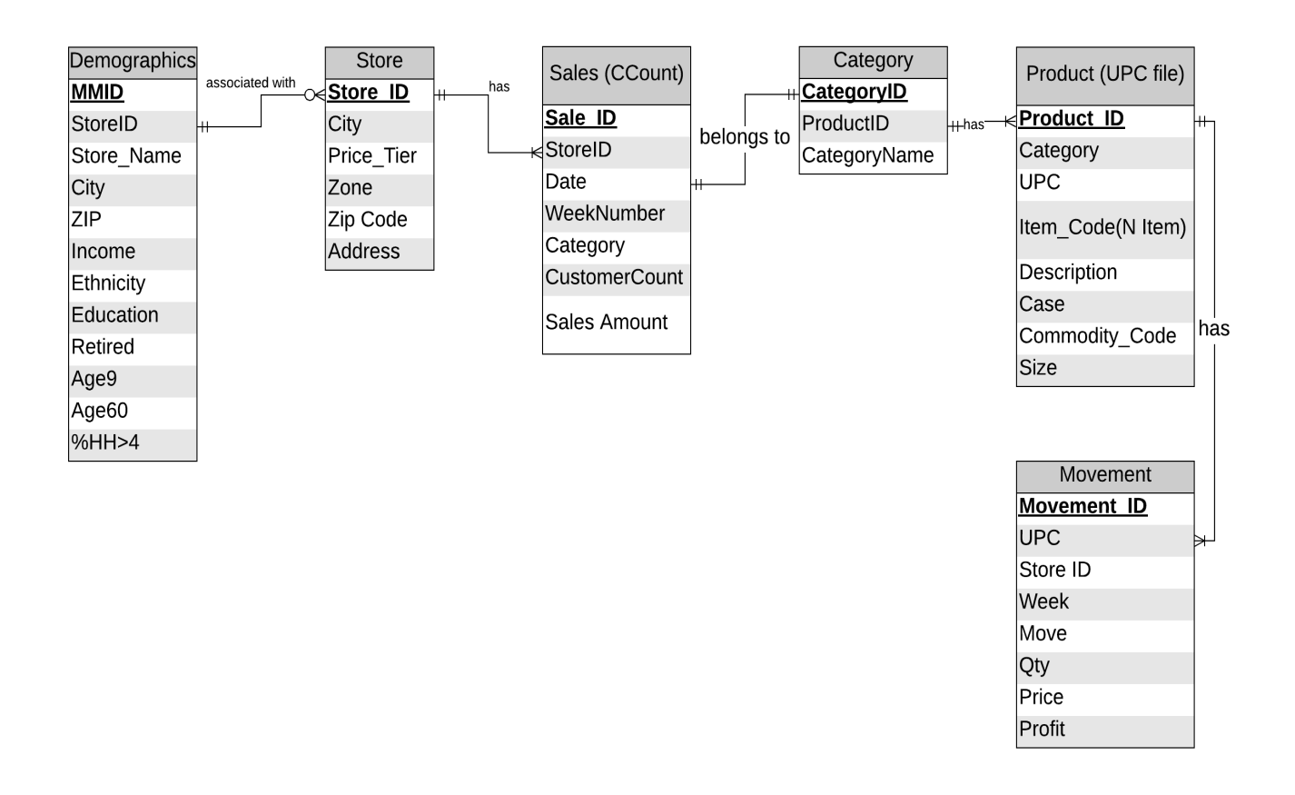

*Database Representation of Tables*

CCount

|  |  |  |  |  |  |
| --- | --- | --- | --- | --- | --- |
| Sales ID | StoreID | Date | Category | Sales | Customer Count |
| 1 | 47 | 880101 | GROCERY | 14900 | 1546 |
| 2 | 47 | 880101 | DAIRY | 3321 | 1546 |
| 3 | 47 | 880101 | FROZEN | 2625 | 1546 |
| 4 | 47 | 880101 | BOTTLE | 0 | 1546 |
| . | . | . | . | . | . |
| 100 | 47 | 880102 | GROCERY | 15881 | 1749 |
| 101 | 47 | 880102 | DAIRY | 3321 | 1749 |
| 102 | 47 | 880102 | FROZEN | 2621 | 1749 |
| 103 | 47 | 880102 | BOTTLE | 0 | 1749 |
| . | . | . | . | . | . |

Store

|  |  |  |  |  |  |
| --- | --- | --- | --- | --- | --- |
| StoreID | City | Price_Tier | Zone | ZipCode | Address |
| 2 | Chicago | High | B | 60439 | 5400 N. Lakewood Avenue |

Demographic

|  |  |  |  |  |  |  |  |  |  |  |  |
| --- | --- | --- | --- | --- | --- | --- | --- | --- | --- | --- | --- |
| MMID | StoreID | Store_Name | City | Zip | Income | Ethnicity | Education | Retired | Age9 | Age60 | %HH>4 |
| 12345 | 2 | Dominick Chicago | Chicago | 60439 | 10.2 | 0.6 | 0.8 | 0.67 | 0.54 | 0.46 | 0.33 |

Category

|  |  |  |
| --- | --- | --- |
| CategoryID | CategoryName | ProductID |
| WTPA | toothpaste | 100002 |
| WTPA | toothpaste | 100001 |

Product

|  |  |  |  |  |  |  |  |
| --- | --- | --- | --- | --- | --- | --- | --- |
| ProductID | UPC | Category | Item_code | Description | Case | CommodityCode | Size |
| 1 | 1192603016 | ANA | 7342431 | CAFFEDRINE CAPLETS 1 | 6 | 953 | 16 CT |
| 2 | 1192662108 | ANA | 7333311 | SLEEPINAL SOFTGEL | 6 | 953 | 8 CT |
| 3 | 1192603016 | ANA | 7342431 | CAFFEDRINE CAPLETS 1 | 12 | 953 | 16 CT |

Movement

|  |  |  |  |  |  |  |  |  |
| --- | --- | --- | --- | --- | --- | --- | --- | --- |
| MovementID | UPC | StoreID | Week | MOve | QTY | DiscountType | Price | Profit |
| 1 | 1060831115 | 5 | 298 | 7 | 1 |  | 0.59 | 15.25 |
| 2 | 1060831115 | 5 | 335 | 2 | 1 | B | 0.51 | 50.98 |

**III.** **Domain Understanding**

“Retail is the process of selling consumer goods or services to customers through multiple channels of distribution to earn a profit. Retailers satisfy demand identified through a supply chain” [2]. There are four core principles to be followed in retail [3]:

1. Customer is most important
2. Understanding your customer
3. 4 Ps - Product, Price, Promotion, Place
4. Location

*Current trends, Strategies & problems in Retails Market*

*Digital Disruption*

The rise of e-commerce has disruptive effect on retail market. Currently, more than 10% of US retail market is dominated by e-commerce. According to Credit Suisse, more than 8640 stores with 147m sq. feet of space closed in 2018 [4]. Below graph supports the underlying trend:

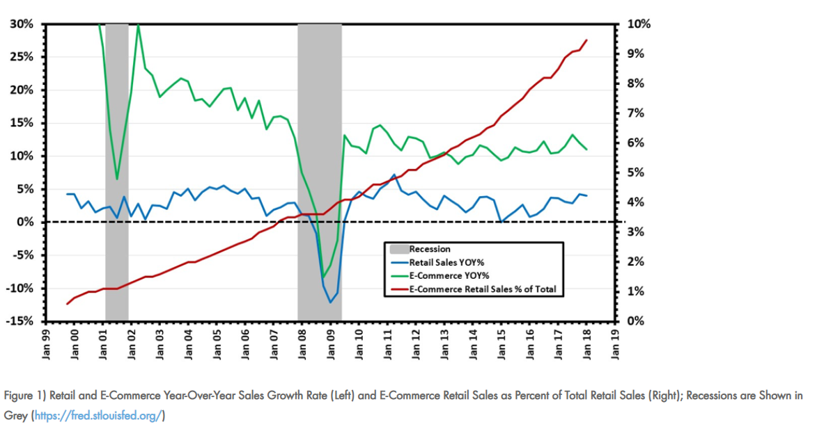

Retails chains should come up with ideas to annul the loss in revenue due to e-commerce by providing in-home service and delivery.

*Customer Customization according to Demographics and Psychographics*

Customers change their shopping pattern frequently and look for personalized experience. Currently retailers analyze demographic data to understand their customer and provide variety in products in which those customers are interested in. Steps involve analyzing customer base, checking competition, understanding product/service, choosing specific demographic to target and finally expanding product base [4]. However, targeting a specific population doesn’t mean you are excluding people who doesn’t fit criteria. [5]

*Marketing Trends by One of the Smartest Supermarket in the United States*

Texas based super mart H-E-B is notorious for promoting local produce by associating them with symbol of pride towards their state. Products are branded like Houston Blend Coffee and Hill Country, which trigger the sentiments in the customers and lead to similar amount of sales as compared to branded products.

Another strategy they use is Neuromarketing by utilization of yellow coupons spread across the aisles. “Put a big yellow price sign next to something, and it will light up people's brains - even if it's not actually a great deal” [6]. In H-E-B’s case, they offer flagged coupons to tear off and to be carried to the checkout counter for scanning which takes Cialdini’s principles of persuasion in account by influencing the customers to engage rather than just pick up a product with discount pasted on the product label.

Utilizing this strategy can lead to promotion of certain products which may have been failing to grasp customer’s attention. Furthermore, by putting these strategies in action, Dominick’s can promote in-house products and utilize coupons in the stores.

*Revenue Vs Profitability*

Retailers face several challenges, the biggest one is to increase profitability. Customers have ever changing demands which are difficult to track. This causes problems in managing the supply chain. There may be products which are always in demand but there is low availability due to supply chain inefficiencies or lack of labor. Retailers also fail to evaluate the potential customers and markets which leads to lower sales. The inventory management system especially during the holiday season is not efficient to manage the inventory across the all the stores. Customers are ever demanding of good quality products which are cheap. To do this, they resort to multiple channels such as online shopping. Retailers are expected to be consistent across all the channels and provide convenience to the customers. Often, retailers fail to estimate their competitors’ capabilities. Small retailers cannot compete with big retailers on price. Conclusively, they need to focus on something other than price to create a good shopping experience. [7]

**IV. Business Questions (Prioritized order)**

1. **Find out stores which are wrongly categorized as Low, Medium or high based on the demographic income?**

It is assumed that tier of a store depends on the income of people of that area. A high tier store’s product and their prices are relatively high as average income in that area is above median income. Overall income of Chicago demographic ranges from 9.8 to 11.5. A low tier store refers to a zone where income lies between 9 and 9.8. A store is considered as medium tier if income lies between 9.8 and 10.7. A high tier store has population whose income lies between 10.8 & above. Apart from income other factors contribute too to decide the tier. However, there are facts represented by our analysis that strongly question the tier of stores.

*Low Tier:*

**Pivot**

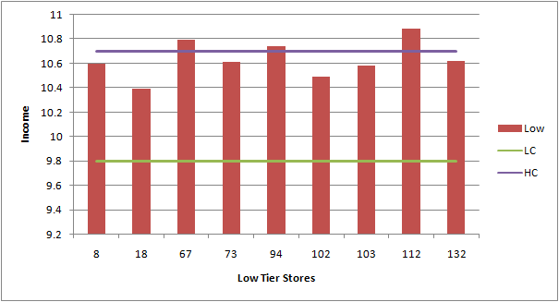

**Justification:** For example, graph shows that average income of families around store 67 and 112 is more than average income of high tier stores (10.8). Store should reconsider tier of these stores.

**ERD:**

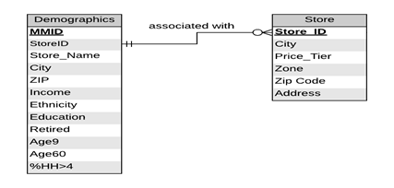

**Data:** *Reference Appendix 1.2*

*Medium Tier:*

**Pivot**

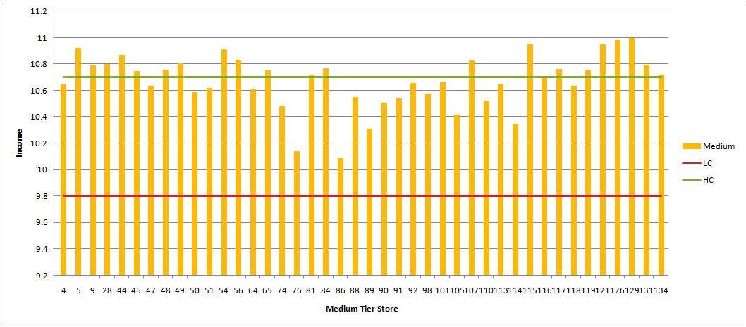

**Justification**: Income of populations around medium tier stores show that there are many stores that cross 10.8 (lower range of high tier stores). These stores should be reclassified to high tier if other factors are minute. This will change the product price and product range according to high tier leading to increase in revenue.

**Data:** *Reference Appendix 1.3*

*High tier:*

**Pivot**

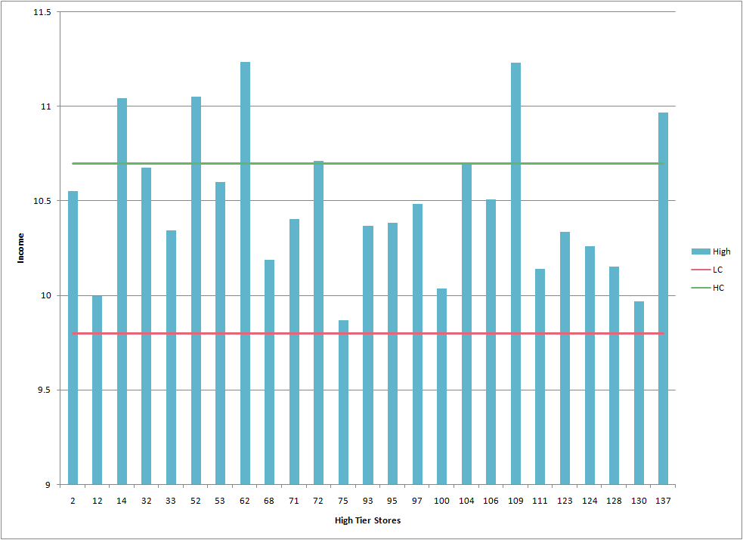

**Justification:** Graph shows that store 75 and 130 are near 9.8 but are considered as high tier store. These should be re-categorized as low or medium stores.

**Data:** *Reference Appendix 1.4*

1. **For the stores where the customer population without car is high, find out the areas in which sale of bulk products is high?**

**Pivot**

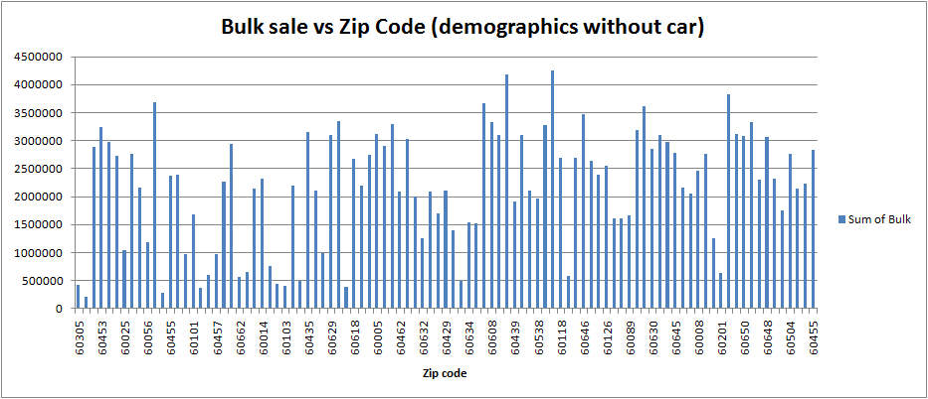

**Justification**: To compete with e-commerce Dominick should start home delivery options. To start with home delivery options, Dominick chain should start with the areas where number of people with no car are more and stores where bulk product sale is more. This data indicates that stores in zip code 60056, 60608, 60118, 60648 have high sales of bulk product with maximum population without car. Enabling home delivery will have positive impact on sales of these area.

**ERD**

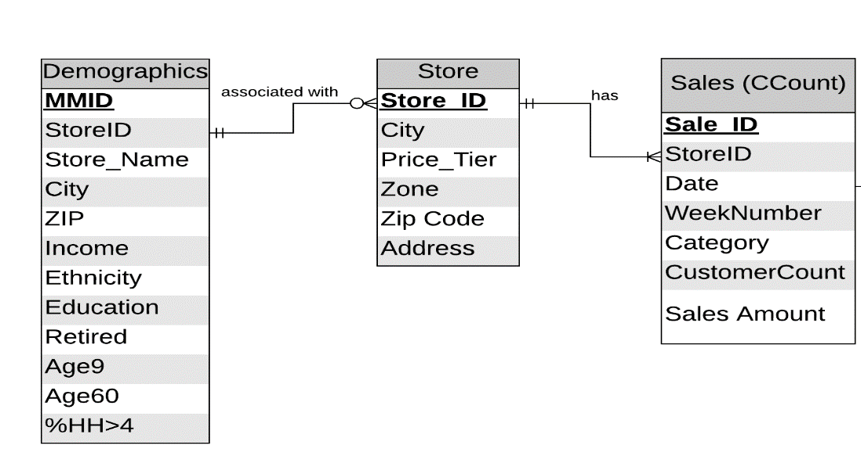

**Data:** *Reference Appendix 1.7*

1. **What is the effect of bonus buy and simple discount on the sale of meat based on tiers?**

**Pivot**

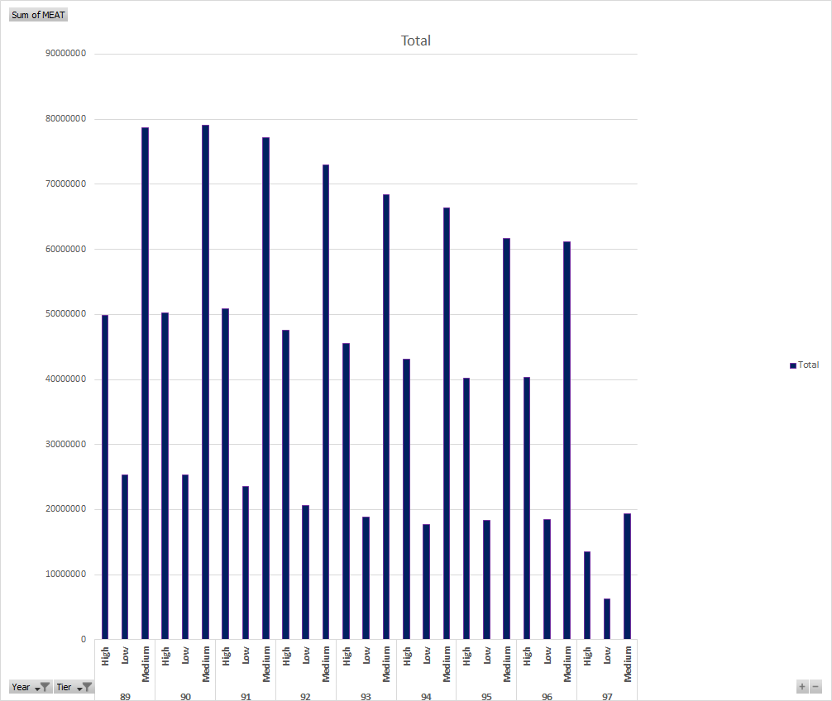

**Justification:**

The CCount file has data which tells us about the meat sales date-wise and week-wise. Our rationale to evaluate meat sales was to understand the impact of tiers on sale based on yearly data. We wanted to evaluate if there is any difference in the sales for high, medium tiers as meat is a popular category. On analysis, we found that the medium tier especially had high net sales as seen above. We expected the sales to be greater for high tier too. But compared to the high tier for all years, medium tier showed relatively high sales. Noticeably, we can see that there is a decline in the sale over the years from 1998-1997. DFF can benefit by analyzing the cause of this decline and coming up with measures to make it an increasing trend over the next few years.

**ERD**

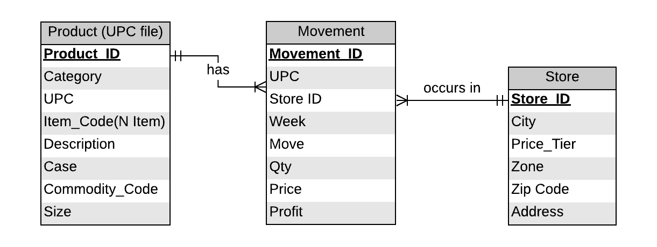

**Data:** *Reference Appendix 1.8*

**4. When toilet papers are bundled, then is there any difference in the sales and profit because of bundling?**

**Pivot**

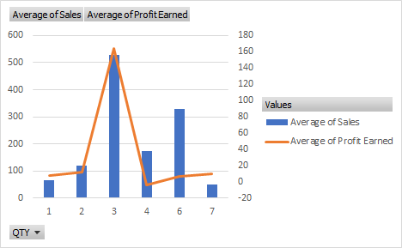

**Justification:** We have data for each category and bundles in which they are sold, and we think that bundling will have an impact on certain products. We took the example of toilet paper as usually customers tend to buy bundles of toilet paper in one go. When we performed analysis on bundled data for toilet papers, we discovered a trend which suggests that when toilet paper is bundled in a group of 3 then it has the highest sales and profits. DFF can increase their sale even more by focusing on the bundles of 3. Moreover, we observed that the bundles of 7 have relatively lower sales but high profits. So DFF can also focus on these bundles furthermore to increase their profitability.

**ERD**

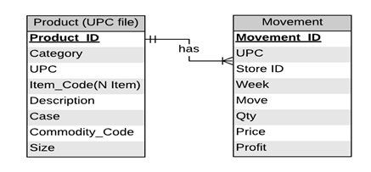

**Data:** *Reference Appendix 1.9*

1. **In high tier stores, find out which of the alcohol-based products dominate sales?**

**Pivot**

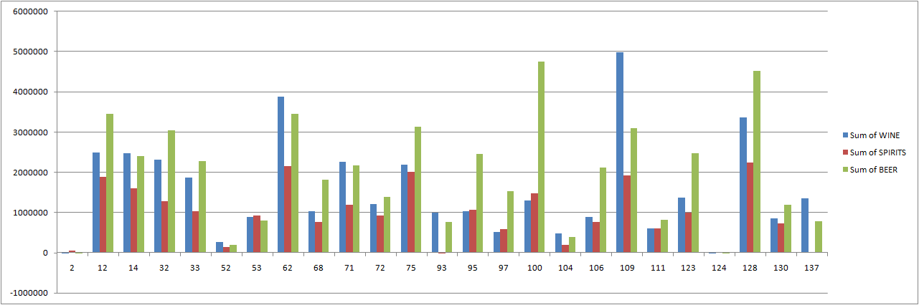

**Justification:** In high tier stores, a major part of sales is due to beer (green) as compared to Wine & Spirit. In order to increase sales from high tier stores, where median income of population is high, stocks of high quality and expensive beer can be increased. This can increase revenue significantly.

**ERD**

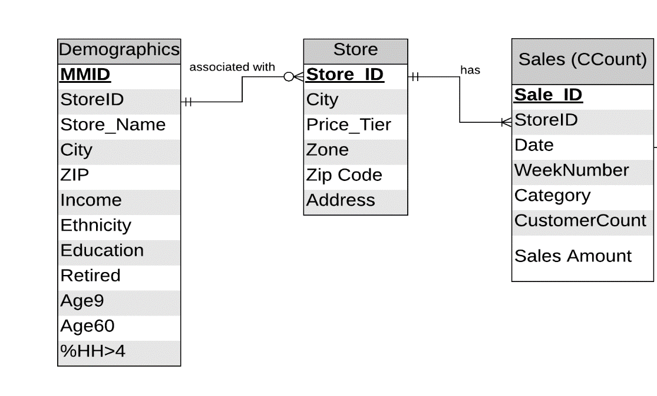

**Data:** *Reference Appendix 1.1*

1. **What is weekly trend of customer in traffic for store 2 between 1995 and 1996?**

**Pivot**

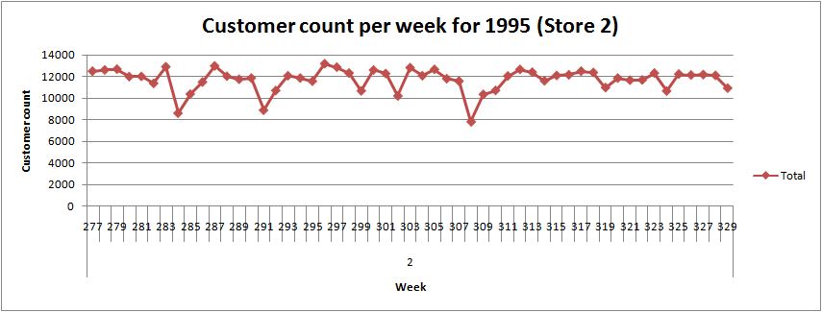

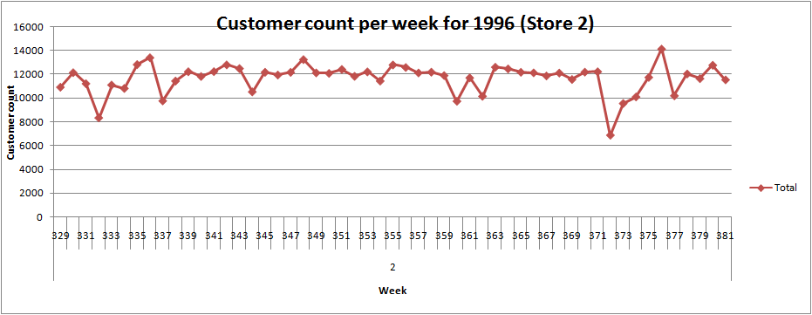

**Justification:** For a sample of stores, we have taken data for year 1995 and 1996 to find out the number of customers visiting the store weekly. Using this data, we have identified a general trend of reduction in customer count during the 1st week of months. During these trough points in graph i.e. the weeks with reduced customer count, we can reduce the staff or let the staff members plan their vacations. This will further lead to reduction of over-stocking and employees count can be reduced to save salary expenses.

**ERD**

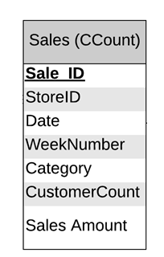

**Data:** *Reference Appendix 1.12*

1. **In categories of frozen products, which method of discount (Coupon or price reduction) gives more profit?**

**Pivot**

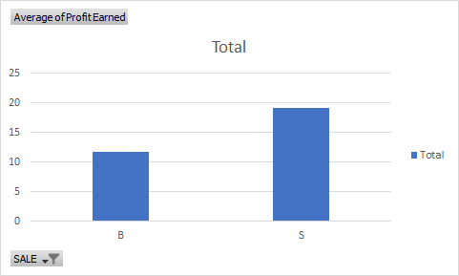

**Justification**: Due to lower shelf life of frozen foods they are often sold on discounted rates to avoid loss. Analysis of profit earned in category frozen entree shows that when simple price reduction is offered, sale and profit is more. Dominick can consider offering simple price reduction rather than offering coupons.

**ERD:**

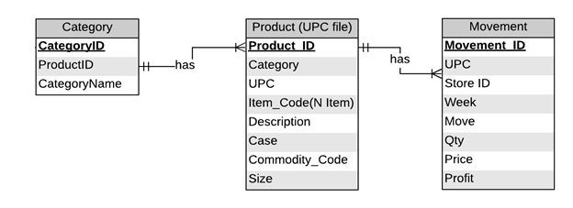

**Data:** *Reference Appendix 1.5*

1. **Which UPCs had most sale in high, medium and low tier for cookies?**

**Pivot (High tier stores)**

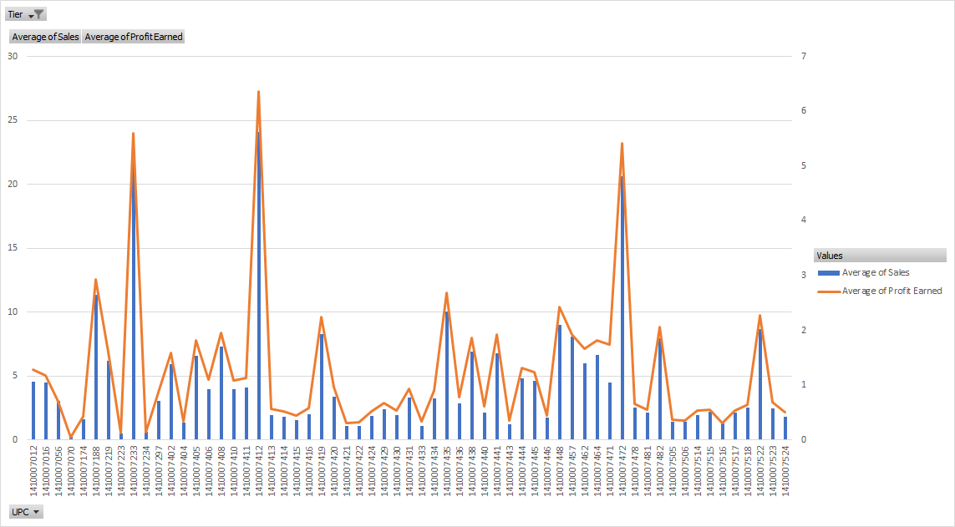

**Pivot (Low tier stores)**

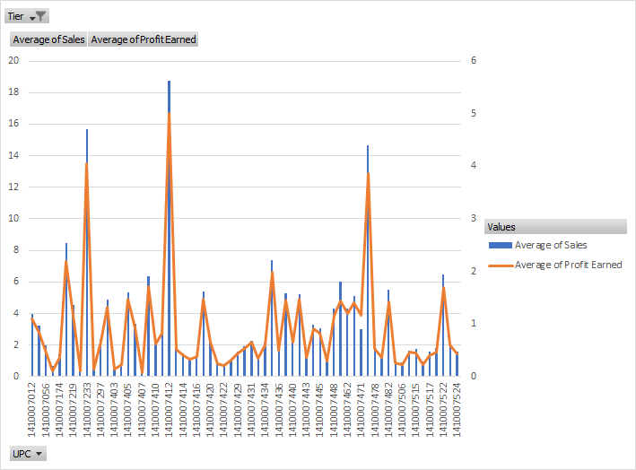

**Pivot (Medium tier stores)**

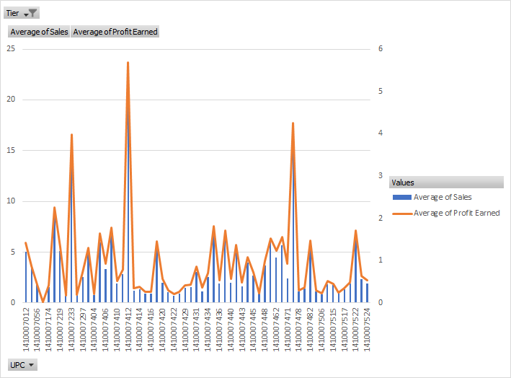

**Justification**: For cookies, the pivot charts show data for different tiers i.e. high, medium and low. We observed that sale of certain UPCs was very high as compared to the others. For example, the sale and profit of UPC is high across all the tiers. This analysis can help the business to promote certain UPCs more than the others. Our analysis on different tiers for the cookies shows that known products, especially high and medium tiers one, are often bought. The business can then focus on the sale of these products by introducing coupons or discounts. They should particularly aim at the high/medium tier to increase profit margins substantially.

**ERD:**

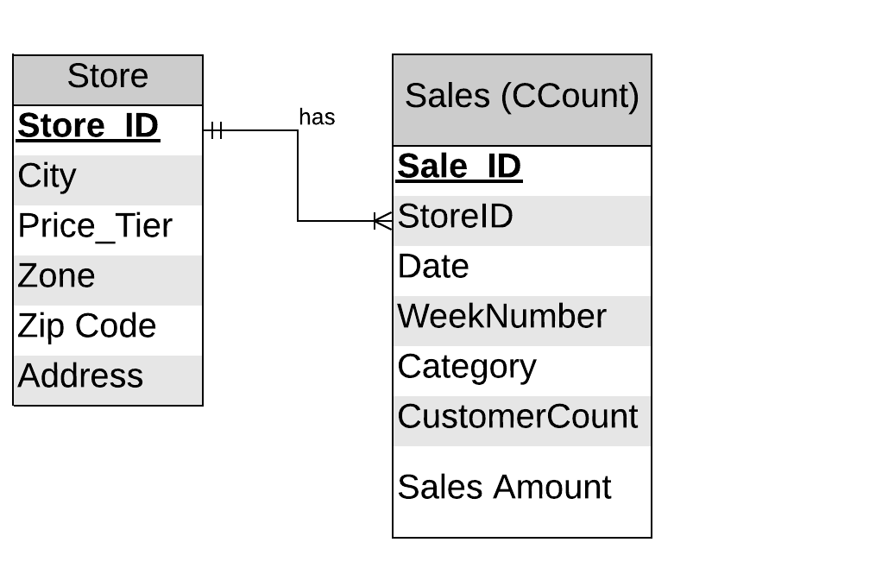

**Data:** *Reference Appendix 1.10*

1. **What is the trend of candies’ sale during Halloween year by year?**

**Pivot**

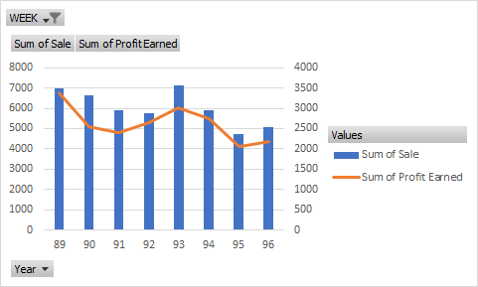

**Justification**: Graph shows the trend of candies during Halloween season from 89 to 96. It can help to predict sales of next year which could range between 4000-5000. This trend can be validated with data from years to come.

**ERD**



**Data:** *Reference Appendix 1.6*

1. **Find out the relation between Bakery sales and bakery coupons redeemed for all the stores?**

**Pivot**

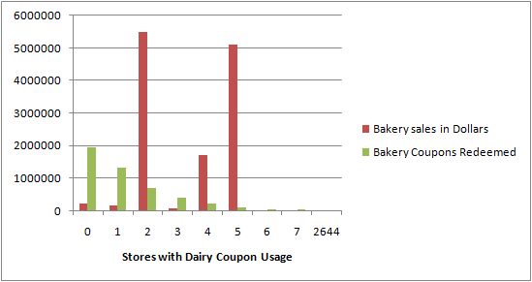

**Justification:** In this business question, we looked at the data given in the CCount table for bakery sales. We wanted to evaluate this amount store wise to see if there is any relevance of the coupons redeemed for bakery items. We noticed that for certain stores such as 0, 1, 2 as shown above, the coupons redemption was high. In contrast, the sale of bakery items was very low. If we see the sale for store 2, 4 and 5, we notice that the bakery sales were extremely high. In this case, the coupons redeemed was not so substantial. This analysis can be further explored to evaluate the difference. One of the strategies by DFF can be to give out more options in coupons or discounts to attract customers in store 2, 4, 5 to eventually increase the sales exponentially. DFF can also try to understand the trend of sales for coupons in stores 0, 1, 2 and strategize to increase the bakery sales in those stores.

**ERD**

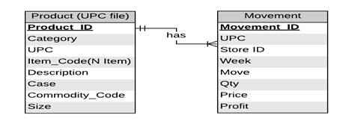

**Data:** *Reference Appendix 1.11*

**References**:

[1] <https://www.forbes.com/sites/lauraheller/2014/01/31/this-is-what-a-failed-supermarket-looks-like/#4677ddb54866>

[2] <https://en.wikipedia.org/wiki/Retail>

[3] <https://www.marketingdonut.co.uk/customer-care/the-five-principles-of-retail>

<https://rsmus.com/what-we-do/industries/consumer-products/retail/top-trends-and-issues-for-retail-in-2019.html>

[4] https://www.inc.com/guides/2010/06/defining-your-target-market.html

[5] <https://extension.psu.edu/understanding-your-customers-how-demographics-and-psychographics-can-help>

[6] <https://www.forbes.com/sites/rogerdooley/2014/01/28/h-e-b/#48e78c8632b8>

[7] <https://pdfs.semanticscholar.org/ed03/e6a1f4fb6fe0b185938e45ef69dc64b4bb69.pdf>)

**Appendix**

* 1. 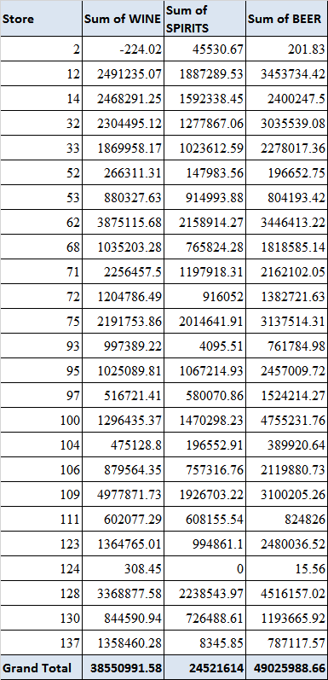
  2. 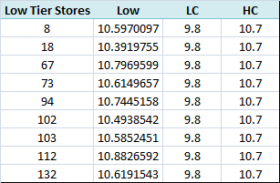

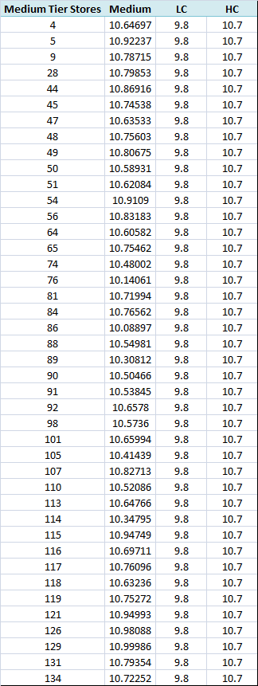

1.4

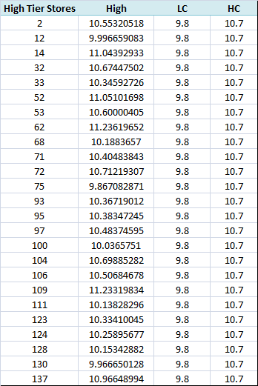

1.5

|  |  |
| --- | --- |
| Promotion Type | Average of Profit Earned |
| B | 11.78158661 |
| S | 19.06941434 |
| Grand Total | 14.04792915 |

1.6

|  |  |  |
| --- | --- | --- |
| Year | Sum of Sale | Sum of Profit Earned |
| 89 | 6999.22 | 3376.3228 |
| 90 | 6651.263 | 2535.38212 |
| 91 | 5901.45 | 2404.6478 |
| 92 | 5754.04 | 2654.70915 |
| 93 | 7104.81 | 3005.81068 |
| 94 | 5910.68 | 2750.00918 |
| 95 | 4712.39 | 2063.50582 |
| 96 | 5086.38 | 2192.1153 |
| Grand Total | 48120.23 | 20982.5028 |

1.7

|  |  |  |  |
| --- | --- | --- | --- |
| STORE | NOCAR | Sum of Bulk | Zip |
| 2 | 0.124603 | 429527.34 | 60305 |
| 4 | 0.055567 | 204587.75 | 60068 |
| 5 | 0.02557 | 2892369.13 | 60067 |
| 8 | 0.075113 | 3237831.36 | 60453 |
| 9 | 0.040128 | 2981199.02 | 60053 |
| 12 | 0.483518 | 2719576.21 | 60660 |
| 14 | 0.026586 | 1043915.44 | 60025 |
| 18 | 0.141975 | 2764367.79 | 60171 |
| 21 | 0.017598 | 2158103.24 | 60103 |
| 28 | 0.054855 | 1183723.9 | 60056 |
| 32 | 0.071701 | 3681720.42 | 60068 |
| 33 | 0.506224 | 288046.5 | 60657 |
| 40 | 0.04633 | 2376585.12 | 60455 |
| 44 | 0.040766 | 2399007.66 | 60558 |
| 45 | 0.020232 | 978547.28 | 60090 |
| 47 | 0.021297 | 1686834.91 | 60101 |
| 48 | 0.021209 | 363853.96 | 60193 |
| 49 | 0.054382 | 610211.83 | 60515 |
| 50 | 0.036434 | 981863.92 | 60457 |
| 51 | 0.025436 | 2272079.47 | 60463 |
| 52 | 0.0149 | 2948795.99 | 60062 |
| 53 | 0.145363 | 558740.95 | 60662 |
| 54 | 0.02084 | 661770.39 | 60540 |
| 56 | 0.031997 | 2151294.25 | 60525 |
| 59 | 0.031318 | 2323421.5 | 60014 |
| 62 | 0.026528 | 770042.09 | 60093 |
| 64 | 0.043621 | 451588.23 | 60181 |
| 65 | 0.015285 | 403082.49 | 60103 |
| 67 | 0.045029 | 2190976.5 | 60521 |
| 68 | 0.305256 | 489008.12 | 60625 |
| 70 | 0.081126 | 3151661.59 | 60435 |
| 71 | 0.153432 | 2102623.47 | 60546 |
| 72 | 0.067621 | 988764.55 | 60646 |
| 73 | 0.133319 | 3095726.85 | 60629 |
| 74 | 0.143645 | 3344568.01 | 60634 |
| 75 | 0.550655 | 390182.56 | 60640 |
| 76 | 0.347964 | 2667431.82 | 60618 |
| 77 | 0.016868 | 2192052.98 | 60061 |
| 78 | 0.01387 | 2750202.77 | 60516 |
| 80 | 0.030875 | 3110142.36 | 60005 |
| 81 | 0.033181 | 2906096.69 | 60056 |
| 83 | 0.043726 | 3295128.98 | 60438 |
| 84 | 0.01332 | 2089748.49 | 60462 |
| 86 | 0.353421 | 3026260.71 | 60618 |
| 88 | 0.049691 | 2010013.5 | 60106 |
| 89 | 0.284283 | 1253452.23 | 60632 |
| 90 | 0.180875 | 2085018.05 | 60617 |
| 91 | 0.072177 | 1698714.88 | 60453 |
| 92 | 0.027058 | 2112668.14 | 60429 |
| 93 | 0.238513 | 1400036.6 | 60202 |
| 94 | 0.012373 | 496998.87 | 60108 |
| 95 | 0.25188 | 1539443.4 | 60634 |
| 97 | 0.084652 | 1523557.9 | 60506 |
| 98 | 0.149392 | 3663537.64 | 60638 |
| 100 | 0.36565 | 3326345.95 | 60608 |
| 101 | 0.06103 | 3094720.3 | 60016 |
| 102 | 0.114071 | 4172533.81 | 60655 |
| 103 | 0.015063 | 1906286.39 | 60439 |
| 104 | 0.034121 | 3108703.1 | 60174 |
| 105 | 0.092157 | 2107330.91 | 60160 |
| 106 | 0.05823 | 1968248.43 | 60538 |
| 107 | 0.042052 | 3273847.15 | 60154 |
| 109 | 0.030239 | 4252568.86 | 60015 |
| 110 | 0.056954 | 2700349.34 | 60118 |
| 111 | 0.334262 | 591340.05 | 60620 |
| 112 | 0.013949 | 2689874.58 | 60090 |
| 113 | 0.144444 | 3467796.24 | 60646 |
| 114 | 0.085277 | 2634598.13 | 60409 |
| 115 | 0.018764 | 2390132.88 | 60540 |
| 116 | 0.060982 | 2549918.33 | 60126 |
| 117 | 0.018772 | 1617513.59 | 60193 |
| 118 | 0.081784 | 1610655.9 | 60053 |
| 119 | 0.015622 | 1670426.1 | 60089 |
| 121 | 0.023876 | 3192807.64 | 60514 |
| 122 | 0.019283 | 3617500.14 | 60194 |
| 123 | 0.241944 | 2859046.69 | 60630 |
| 124 | 0.29272 | 3096226.07 | 60302 |
| 126 | 0.02345 | 2983417.63 | 60187 |
| 128 | 0.340148 | 2777635.09 | 60645 |
| 129 | 0.024509 | 2168587.81 | 60047 |
| 130 | 0.407352 | 2055944.68 | 60649 |
| 131 | 0.037447 | 2455545.95 | 60008 |
| 132 | 0.032774 | 2761699.55 | 60443 |
| 134 | 0.021372 | 1256478.9 | 60185 |
| 137 | 0.104094 | 638306.03 | 60201 |
| 301 | 0.013213 | 3833573.14 | 60462 |
| 302 | 0.036081 | 3115662.18 | 60139 |
| 303 | 0.275086 | 3090437.25 | 60650 |
| 304 | 0.411329 | 3325924.31 | 60614 |
| 305 | 0.051017 | 2309175.39 | 60050 |
| 306 | 0.064158 | 3057769.01 | 60648 |
| 307 | 0.039286 | 2322793.29 | 60073 |
| 308 | 0.113115 | 1745790.84 | 60160 |
| 309 | 0.047555 | 2764393.03 | 60504 |
| 310 | 0.030871 | 2145682.99 | 60004 |
| 312 | 0.063657 | 2230005.83 | 60445 |
| 315 | 0.049952 | 2839280.8 | 60455 |

1.8

|  |  |
| --- | --- |
| Year & Tiers | Sum of MEAT |
| 89 | 153880949.1 |
| High | 49851107.74 |
| Low | 25324790.45 |
| Medium | 78705050.92 |
| 90 | 154609983.4 |
| High | 50169964.99 |
| Low | 25323391.25 |
| Medium | 79116627.11 |
| 91 | 151547740.1 |
| High | 50898534.76 |
| Low | 23506119.49 |
| Medium | 77143085.81 |
| 92 | 141159609.7 |
| High | 47582555.42 |
| Low | 20635103.03 |
| Medium | 72941951.23 |
| 93 | 132774657.7 |
| High | 45533074.56 |
| Low | 18825978.34 |
| Medium | 68415604.8 |
| 94 | 127200794.3 |
| High | 43113963.68 |
| Low | 17768582.22 |
| Medium | 66318248.36 |
| 95 | 120168615.3 |
| High | 40168590.55 |
| Low | 18349791.36 |
| Medium | 61650233.39 |
| 96 | 119899745.8 |
| High | 40344226.99 |
| Low | 18457280.75 |
| Medium | 61098238.07 |
| 97 | 39132831.16 |
| High | 13483313.47 |
| Low | 6278639.57 |
| Medium | 19370878.12 |
| Grand Total | 1140374926 |

1.9

|  |  |  |
| --- | --- | --- |
| Bundle | Average of Sales | Average of Profit Earned |
| 1 | 65.27789 | 8.260493 |
| 2 | 119.4916 | 12.00605 |
| 3 | 528.9431 | 163.9724 |
| 4 | 172.9482 | -3.41767 |
| 6 | 328.9628 | 7.251246 |
| 7 | 50.37261 | 10.03501 |
| Grand Total | 65.90712 | 8.335087 |

1.10

|  |  |  |
| --- | --- | --- |
| UPC | Average of Sales | Average of Profit Earned |
| 1410007012 | 4.384428 | 1.226138 |
| 1410007016 | 3.633641 | 0.945096 |
| 1410007056 | 2.311949 | 0.534848 |
| 1410007070 | 0.608514 | 0.102474 |
| 1410007174 | 1.489408 | 0.389054 |
| 1410007188 | 9.442057 | 2.432816 |
| 1410007219 | 5.11865 | 1.31273 |
| 1410007223 | 0.547326 | 0.134451 |
| 1410007233 | 17.60341 | 4.552681 |
| 1410007234 | 0.637829 | 0.156388 |
| 1410007297 | 2.63538 | 0.740889 |
| 1410007402 | 5.18476 | 1.395821 |
| 1410007403 | 0.429607 | 0.137603 |
| 1410007404 | 0.997156 | 0.256517 |
| 1410007405 | 5.7673 | 1.594558 |
| 1410007406 | 3.518518 | 0.982424 |
| 1410007407 | 0.221964 | 0.071095 |
| 1410007408 | 6.707648 | 1.791357 |
| 1410007410 | 2.685742 | 0.741502 |
| 1410007411 | 3.270521 | 0.909736 |
| 1410007412 | 20.62517 | 5.474156 |
| 1410007413 | 1.702379 | 0.491922 |
| 1410007414 | 1.536171 | 0.439979 |
| 1410007415 | 1.207981 | 0.346171 |
| 1410007416 | 1.480713 | 0.425516 |
| 1410007419 | 6.257317 | 1.697188 |
| 1410007420 | 2.574415 | 0.738901 |
| 1410007421 | 0.949296 | 0.274452 |
| 1410007422 | 0.853159 | 0.249834 |
| 1410007424 | 1.313253 | 0.376025 |
| 1410007429 | 1.82841 | 0.517323 |
| 1410007430 | 1.855331 | 0.519711 |
| 1410007431 | 2.662865 | 0.75069 |
| 1410007433 | 1.044559 | 0.331283 |
| 1410007434 | 2.546091 | 0.707441 |
| 1410007435 | 8.050003 | 2.158158 |
| 1410007436 | 2.117222 | 0.591408 |
| 1410007438 | 5.880256 | 1.599169 |
| 1410007440 | 2.179403 | 0.622918 |
| 1410007441 | 6.041874 | 1.698873 |
| 1410007443 | 1.248802 | 0.365389 |
| 1410007444 | 3.793344 | 1.036033 |
| 1410007445 | 3.415281 | 0.922931 |
| 1410007446 | 1.289892 | 0.338155 |
| 1410007448 | 5.616146 | 1.527805 |
| 1410007457 | 6.681319 | 1.591235 |
| 1410007462 | 4.813176 | 1.338268 |
| 1410007464 | 5.59313 | 1.537961 |
| 1410007471 | 3.483946 | 1.346603 |
| 1410007472 | 16.72433 | 4.393285 |
| 1410007478 | 2.025158 | 0.533507 |
| 1410007481 | 1.617164 | 0.419084 |
| 1410007482 | 6.251552 | 1.617076 |
| 1410007505 | 1.143223 | 0.29432 |
| 1410007506 | 1.045518 | 0.26883 |
| 1410007514 | 1.759799 | 0.492661 |
| 1410007515 | 1.902872 | 0.477356 |
| 1410007516 | 1.045954 | 0.255587 |
| 1410007517 | 1.715455 | 0.433174 |
| 1410007518 | 2.036305 | 0.515899 |
| 1410007522 | 7.154801 | 1.874786 |
| 1410007523 | 2.315022 | 0.645995 |
| 141000752 | 1.736384 | 0.484798 |
| Grand Total | **4.5649** | **1.2266** |

1.11

|  |  |  |
| --- | --- | --- |
| Store | Bakery sales in Dollars | Bakery Coupons Redeemed |
| 0 | 219848.2 | 1949513 |
| 1 | 164017 | 1309851 |
| 2 | 5496520 | 682590.2 |
| 3 | 59118.35 | 385019.7 |
| 4 | 1709304 | 223054.4 |
| 5 | 5102597 | 79931.5 |
| 6 | 5403.62 | 37551.05 |
| 7 | 3106.9 | 21653.23 |
| 2644 | 218.95 | 1083.38 |

1.12

